Summer I 2017

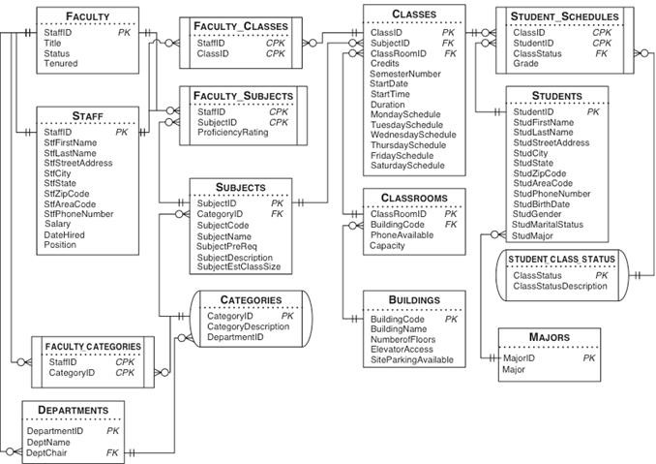

- Show all information of professor who taught the most classes.
- What is the most popular major? Use correct aggregate functions to create appropriate measure(s) for popular major.
- Show all info of female students who took more morning Monday class(es) (before 12:00 pm) than afternoon Monday class(es) (between 12:00 pm and 5:00 pm).
- Do we have more students who are single than who are married? Must return ‘Yes’ or ‘No’.
- For each student, display his/her currently taking classes that has the latest start time.

